metaCAMPUS — Employment Agreement

This Employment Agreement is entered into as of December 17 , 2026 by and between metaCAMPUS LLP, a Washington State Limited Liability Partnership organization operating as a non-profit Decentralized Autonomous Organization (DAO) , and Rohan Reddy Solipuram

1. Position
The Company hereby elects to employ Employee in the position of Co-Founder, Software Engineering. Employee will report directly to the Senior Vice President(SVP) or the equivalent leadership role designated under the DAO’s governance structure.

Employee’s responsibilities include, but are not limited to: • Designing, building, and maintaining core components of the Company’s software systems and DAO infrastructure; • Participating in product planning, decentralized governance discussions, and feature development; • Writing, testing, deploying, and documenting code.

Employee agrees to perform these duties faithfully and to the best of their ability.

2. Co-Founder Acknowledgment
Employee is also acknowledged as a Co-Founder of the Company. This Agreement governs employment-related obligations only. Founding status, governance participation, and any rights related to DAO membership are governed separately under the DAO Governance Framework, Operating Guidelines, Contributor Membership Policies, or other governance documents adopted by the Company at a future date.

Because the Company is a non-profit organization, Employee acknowledges that “Co-Founder” does not imply equity ownership or profit participation.

3. Employment Status and Term
Employee will serve as a full-time employee for a fixed term of ONE (1) year, beginning on the Start Date and ending on December 24, 2026 (“Employment Term”). Any continuation beyond this term will require a new written agreement, executed by both parties.

Employee may maintain a flexible schedule related to academic or personal responsibilities, provided core duties and deliverables are met as determined by the SVP.

The parties expressly agree that Employee’s employment is NOT “at-will,” and that this Agreement provides a fixed term and specific termination conditions, as set forth in Section 6.

4. Compensation
Employee will be paid a TOTAL salary of $220,000 USD for the entire ONE-YEAR Employment Term. This salary will be divided and paid according to the Company’s standard payroll schedule and will be subject to applicable tax withholdings.

No additional salary is guaranteed beyond the one-year term unless a new agreement is executed.

5. EQ2 Governance Participation (Non-Equity Compensation)
Because the Company is a non-profit organization, it does not issue equity, ownership shares, or stock options. Instead, the Company utilizes EQ2 Smart Contracts, a blockchain-based governance and transparency framework that provides non-financial participation rights.

Employee will receive EQ2 Governance Units (“EQ2 Units”) in accordance with the Company’s EQ2 Participation Framework. EQ2 Units: • Are not equity, stock, ownership, or profit-sharing instruments; • Represent non-financial governance participation within the DAO; • May be used to propose, discuss, and vote on DAO decisions; • Provide a transparent, on-chain record of contribution, reputation, and involvement; • Are issued and managed through smart contracts to enhance transparency and accountability.

The EQ2 framework supports: • Decentralized governance • Transparent and automated funding flows • Non-financial incentives and contributor reputation • Increased accountability • Reduced administrative overhead • Innovative nonprofit-compliant funding mechanisms • Greater donor and community engagement

EQ2 Units will follow a vesting schedule as defined by the Company, but they remain strictly governance-based and non-financial.

Specific allocations, vesting terms, and governance powers will be defined in a separate EQ2 Governance Agreement, which shall be incorporated by reference.

6. Term and Termination (Non-At-Will)
6.1 Fixed Term. This Agreement covers the Employment Term described in Section 3. Except as provided in this Section 6, Employee is entitled to continue employment, and to receive the salary set forth in Section 4, through the end of the Employment Term.

6.2 Termination by Company for Cause. The Company may terminate Employee’s employment before the end of the Employment Term for “Cause.” For purposes of this Agreement, “Cause” means:

(a) willful misconduct or gross negligence in the performance of Employee’s duties that materially harms the Company; (b) material breach of this Agreement or of any written Company policy, after written notice and a reasonable opportunity (not less than ten (3) days) to cure, if curable; (c) fraud, embezzlement, or theft in connection with Employee’s duties; (d) conviction of, a felony or a crime involving moral turpitude that materially impairs Employee’s ability to perform their role; or (e) intentional violation of any applicable law or regulation in connection with services to the Company that materially harms the Company.

In the event of termination for Cause, Employee will be entitled only to (i) salary earned through the effective date of termination.

6.3 Termination by Company Without Cause. The Company may terminate Employee’s employment before the end of the Employment Term without Cause only if it makes whole the Employee, for the remaining unpaid salary through the end of the one year term of employment.

6.4 Termination by Employee. Employee may terminate this Agreement before the end of the Employment Term by providing at least fourteen (14) days’ written notice to the Company. In such case, Employee will be entitled to salary compensation through the final day of employment.

6.5 Effect on Governance Participation. Termination of employment will never terminate continuation of governance participation or Employee's EQ2 Unit rights; such rights will be governed exclusively by the Company’s DAO policies and the EQ2 Governance Participation Agreement.

7. Confidentiality & IP Assignment
Employee agrees to maintain confidentiality of the Company’s proprietary information. All inventions, code, designs, documents, and intellectual property created during employment that relate to the Company’s mission are the exclusive property of the Company as incorporated through the Proprietary Information and Inventions Assignment Agreement (PIIAA).

8. Remote Work
Employee will perform all duties remotely. The Company does not require Employee to work from any physical office location. Employee may continue working remotely from any location within the United States unless otherwise assigned in writing.

9. Signatures
Employee:

Name: Rohan Reddy Solipuram

Address: 13 Goulding st , APT 1 , Worcester , MA - 01609

Signature: 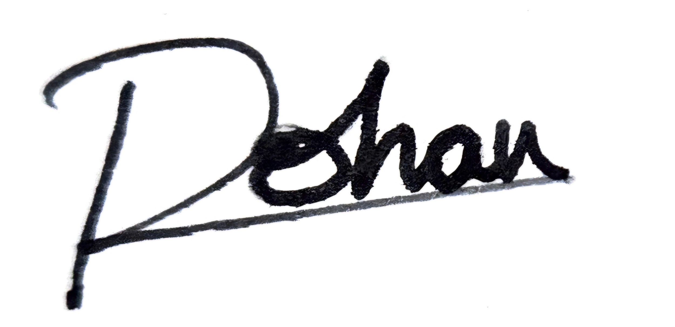

Date: 2nd December 2025

Company:

Name: Mr. George Artem

Title: Managing Partner

Signature: _//s// Mr. George Artem

Date: 11.26.2025

